A Fresh Volunteer Among Soltari Priests: What Can You Learn?
Anthony Alongi
The World Championships in Toronto, like Worlds every year, was a prestigious event: only the best from each country are invited to play. As an occasional freelancer for Sideboard, I have been fortunate enough to get a front-row seat for most of the action. (Goodness knows I'll never get there as a player, with my Extended Grave Pact deck.) Here's what I learned at Toronto:

1) Canada is not part of the United States. Call me an arrogant American, but this stunned me. I was fairly certain, from talking with a few people I thought were Canadians (though it now appears they were from Fiji, or perhaps New York), that all the paperwork had been completed on this transaction. Alas, our neighbors to the north haven't even completely stopped talking French. (Actually, I understand the French firmly believe the Canadians stopped talking French about 100 years ago; but that's another topic.) Call me crazy, but I think these Canadians are firmly committed to remaining their own nation, with their own cultural identity, heritage, and bacon. I guess I can live with that. Still, I was mightily disappointed: Canada would have added a touch of class to our enterprise.
Actually, I first realized something was amiss when I stepped off the plane at the Toronto airport. The customs agent asked me for my passport, which got me all flustered, and soon I was pitching underwear frantically out of my travel bag, looking for a little booklet I knew I didn't have. Let me tell you, that is one frigid feeling in the pit of your stomach when a customs agent in a foreign country is asking you for a document you didn't think you needed. (Fortunately, I didn't. The documents I had on me, and my obvious bone-headedness, clearly identified me as an American.) The agent was very friendly, and very professional. She was also very cute; though my wife heard from me later on that I bravely slew a smelly ogre on the border to gain access to this other-worldly kingdom.
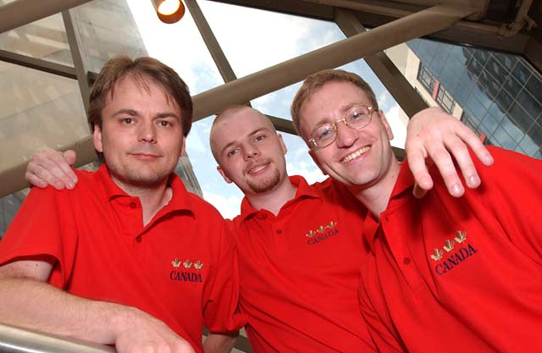
It's team Norway!
2) European teams are the best teams to report on. With all due respect and congratulations to my "peeps" on this side of the Atlantic (and on this side of the ogre-infested border), I had the most fun covering the Swedish and Hungarian Rochester draft teams. While press are allowed to sit at the deck construction tables, players aren't forced to talk to us. But after they had made most major decisions, and were comfortable with the time they had, these guys not only talked with me about their card choices and metagame strategies, they laughed and joked, asked me about what I thought of Worlds (not regarding the specific drafts or card choices, of course... that would have been both inappropriate, and rather foolish of them), and were just generally fun to be around.
As a result, I was able to do better, more detailed, and more intimate coverage of the event. And that's good for the readers, the writer, and the players themselves.
Another country I enjoyed checking in on was the Ukraine, since I had played against team member Boris Zlotoiabko during a side event the evening before. That team turned in a solid performance for the day; and it was great watching them savor their wins at a tournament that wasn't easy for them to travel to. Boris and his colleagues were easy to get to know - and I didn't have to be a reporter for that. And that brings me to my next point.
3) You should be playing in the side events. Whenever a Grand Prix or Pro Tour stop comes within drivable distance, you should be there, and you should play at the side events. These are terrific opportunities to get to know and play against different people from around the world - a Level III judge from Japan, or a champion from eastern Europe, or just someone else who lives near your city whom you've never met before. The skill levels are quite varied, and you can both compete with some of the best players in the world, and relax with someone who's as new to this scene as you are, all at the same draft table. There are also qualifiers for upcoming events, and with most of the heavy hitters accounted for at the main event, what better time for you to make your move?
4) The Pros? Still short. I mentioned this in a similar report after Pro Tour-Chicago; but it bears repeating. These guys are tiny, tiny people. How they lift the decks up over their heads to get a good riffle shuffle, I have no idea. And then when everyone started playing tiny saproling tokens... well, it was like some kind of shrub-and-gnome festival.
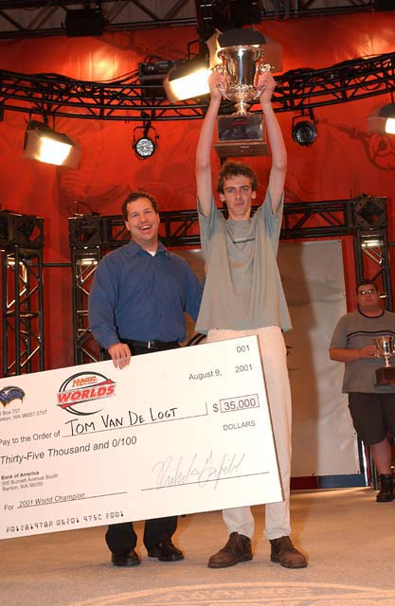
Of course, I'm exaggerating. Not all pros are that small. World Champion Tom Van de Logt must have felt like he was Gilbert (or was it Sullivan?) among the Lilliputians. But even as tall as he is, he is not as imposing as you would expect a Magic player at the top of the game to be. We chatted quite a bit during the last day, and I was pleasantly surprised by his open manner
My point is, you meet these guys, and you expect Kai Budde to smash through stone, and Ben Rubin to leap tall buildings in a single bound, and Alex Borteh to summon fish, or something. (Heeeeeey...) You expect them to glare at you suspiciously, like you're trying to "steal their tech." But virtually all of these people are quite approachable, and open to any intelligent Magic-related conversation you may have for them. (Hint: rambling on about your really cool Standard, five-color minotaur deck, which only lost at the last Grand Prix because your opponent was a savage cheater and kept top-decking cards that matched her mana, is not considered intelligent conversation. In fact, it's barely considered Magic-related.)
So when you at an event like this, go up to one or two of these players when they're alone. Tell them you enjoy watching their game and that you've learned a lot from them, that you look forward to their reports on the internet, and so on.
After you've made nice, have a couple of questions ready for them. What do they think of the metagame today... are they seeing the kinds of decks they expected? What decks have they beaten? You don't need to cross-examine them; just share a little good will, learn a little bit, thank them for their time, and move on.
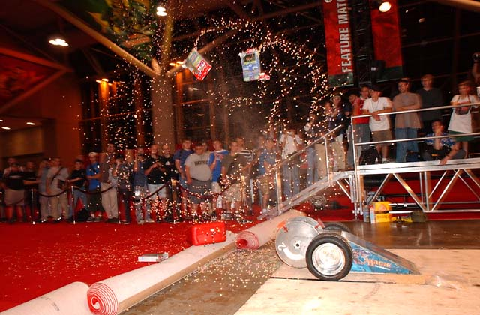
5) There are other things to see and do. At Worlds, Wizards had a BattleBots demo team come in and show off one of the new 'bots. (I'm not an expert on the show; but Comedy Central repeats episodes frequently enough that I recognized the model in Toronto as a larger, heavier version of Atomic Wedgie.) I don't know exactly how this one worked; all I know is that when I walked by the first time, it was puttering around a small plastic box, under the calm control of its master. When I walked by again ten minutes later, there was confetti and pieces of box all over the place. It reminded me of eating out with Jeff Donais.
6) The games you watch are among the finest Magic you'll ever see. Of course, the point of a World Championship is for the best in the world to face off. That alone should be enough to draw you to one of these events. While Magic may never become a widely accepted spectator sport, it is still very entertaining to watch once you learn the matchup and the players. Very little has taught me more about sound Magic play than watching Van de Logt, Budde, Finkel, Maher, Ruel, and Mori make their draft picks, play out their creatures, choose their discards, and so on. At every Pro Tour stop, the DCI takes special care to raise a platform around the Feature Match area. That's not for the players, folks. That's for you. Get up there, watch, and learn. Talk over the plays with your friends. As you get to know more accomplished players, ask them what they thought of play X or Y. (Note: do this after the match is over.)
And while you're up on that platform, maybe you could also spare a moment to fetch some water for the parched throat of the reporter who's sitting down there...the dashing Italian-American with the beard and a Grave Pact in his shirt pocket? Thanks.

